1. How many types (kinds) of pets are there?

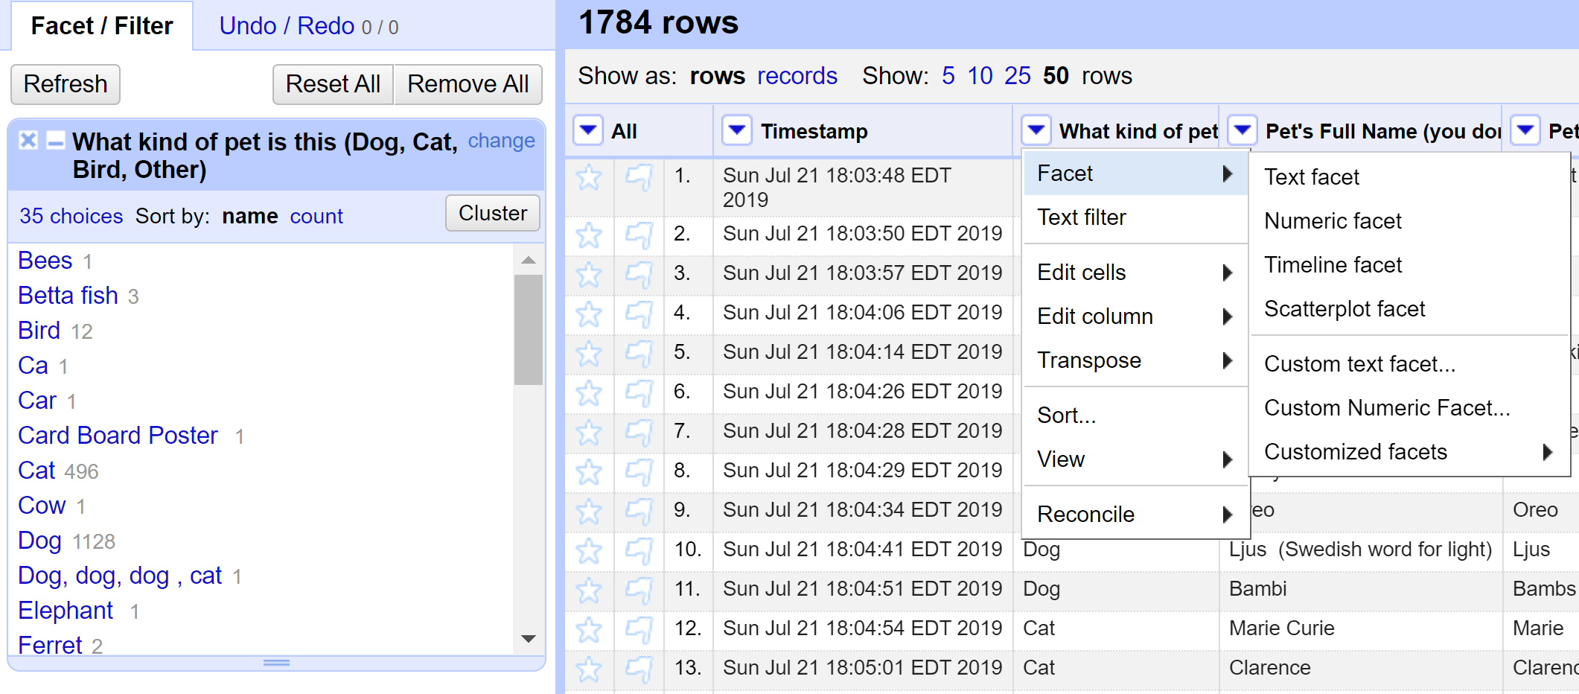

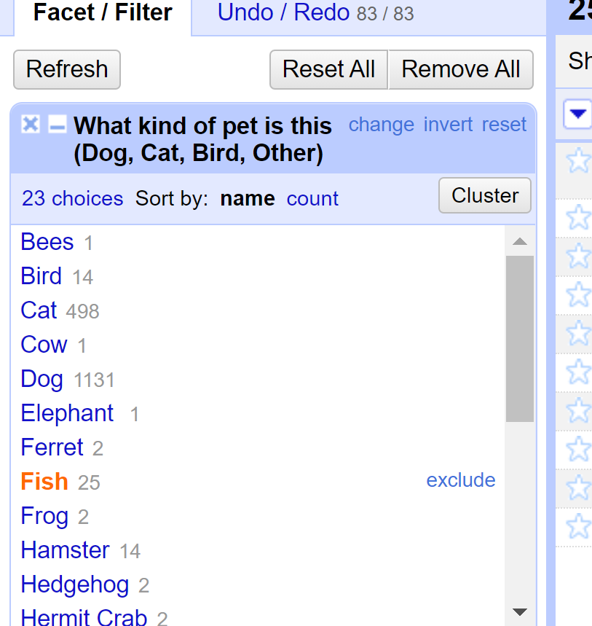

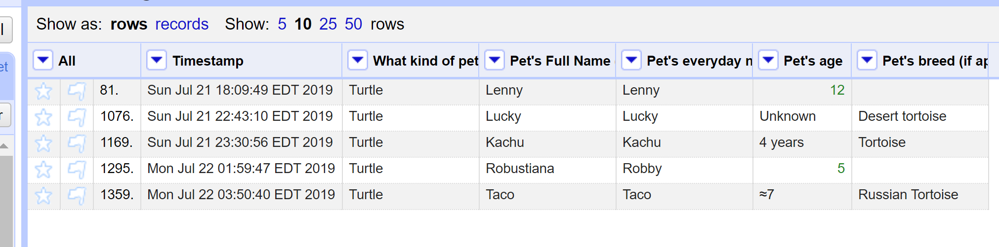

Finally, I could figure out **19** different pets, but it shows like there are ***20*** types of pets. There is one choice that is ***others*** which contains all trash that do not belong to pets.

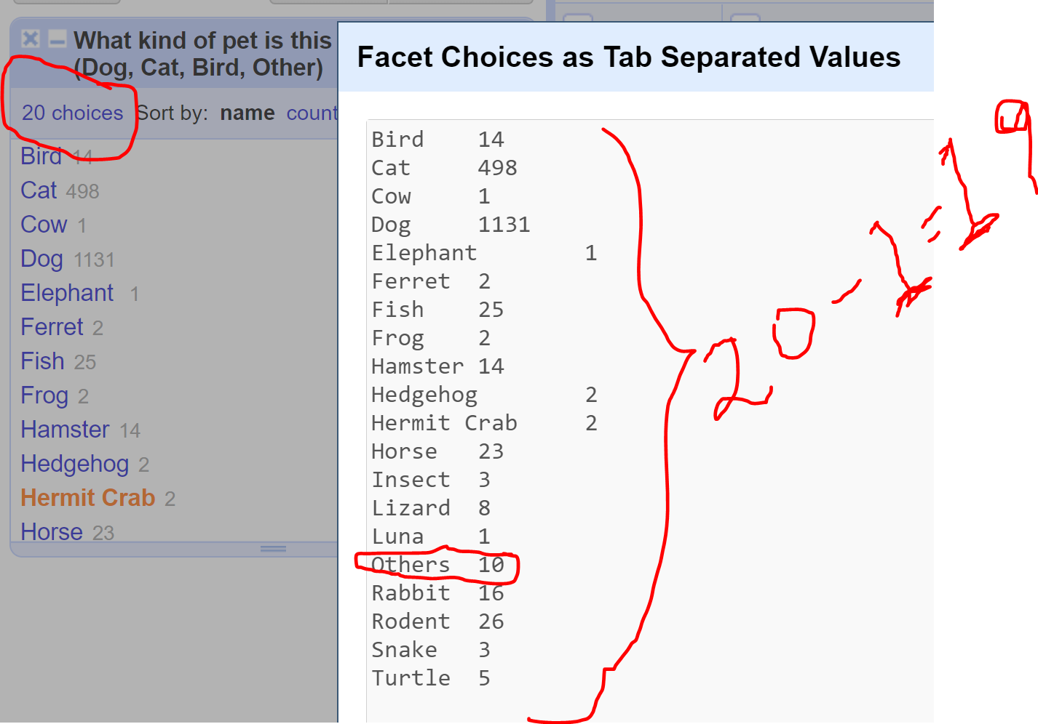

1. **How many dogs?**

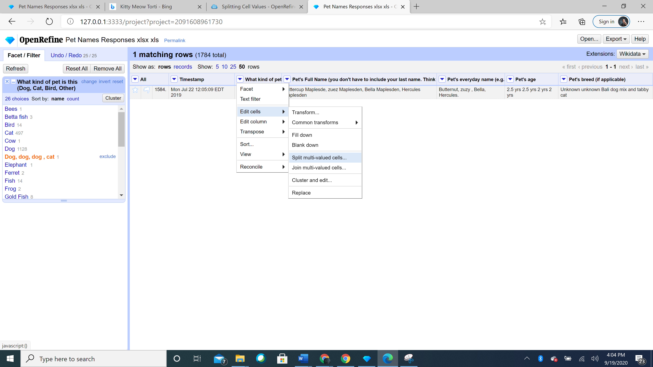

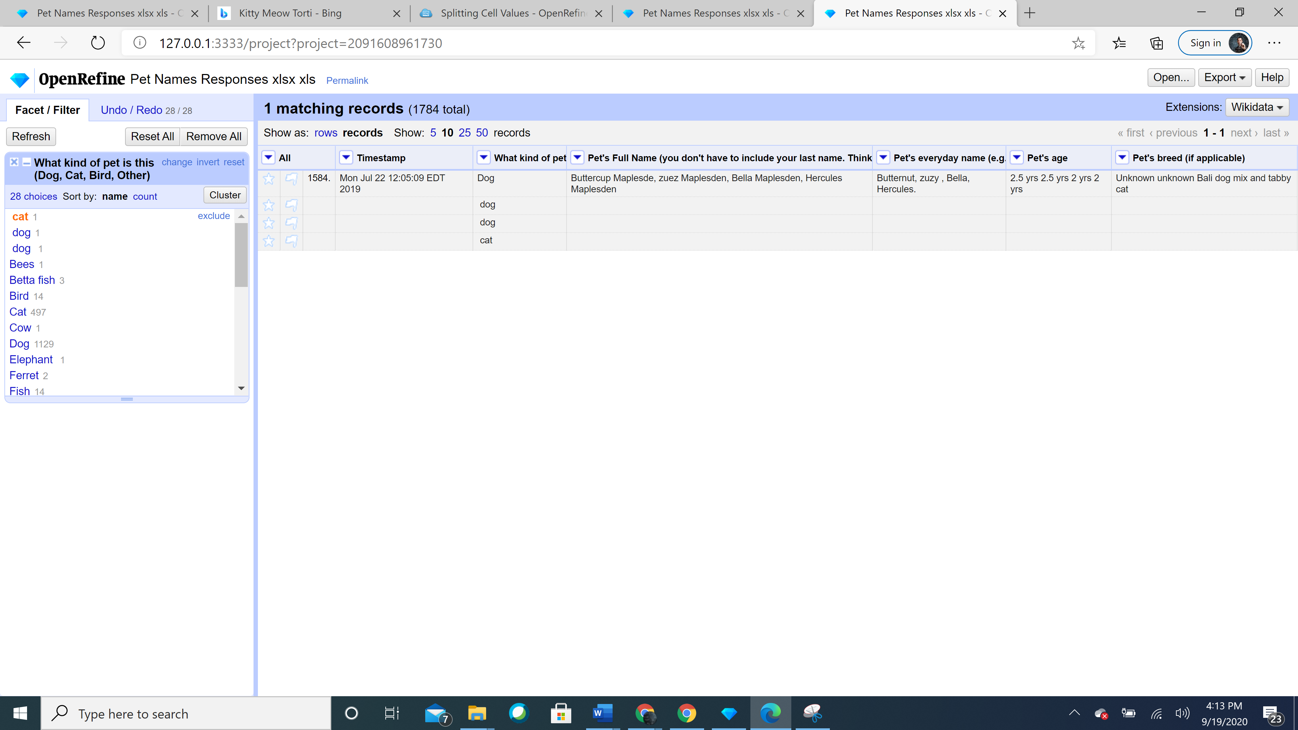

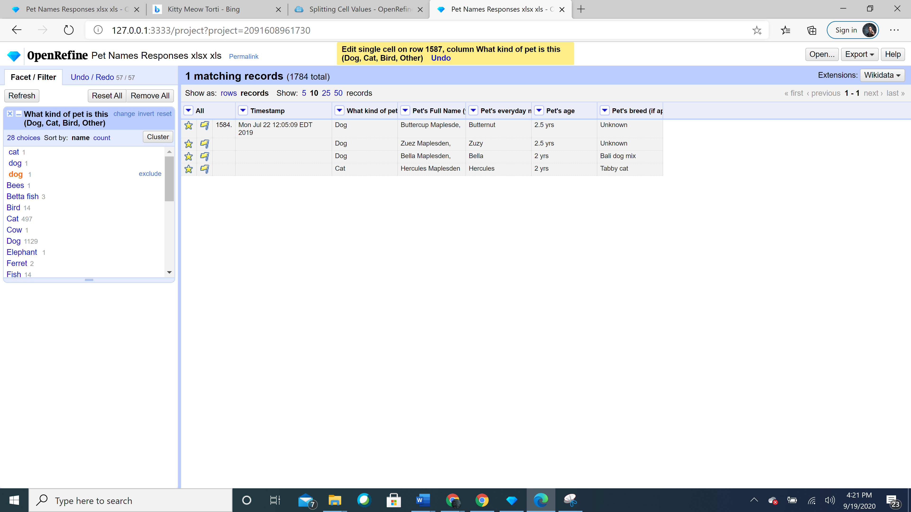

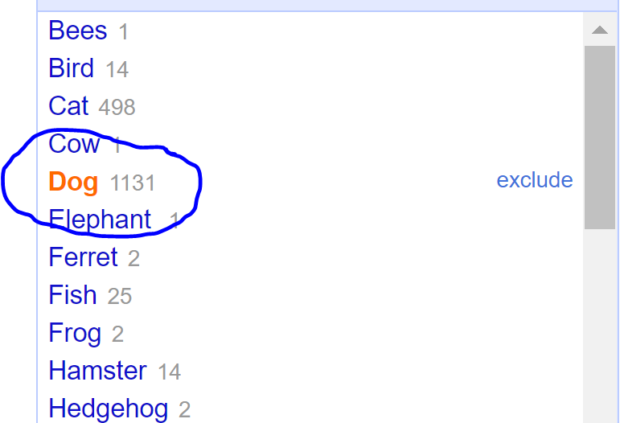

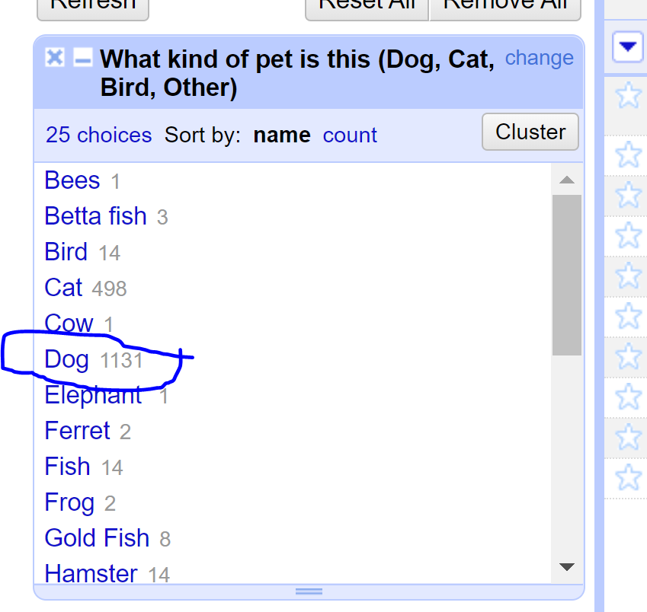

1. How many breeds of dogs?

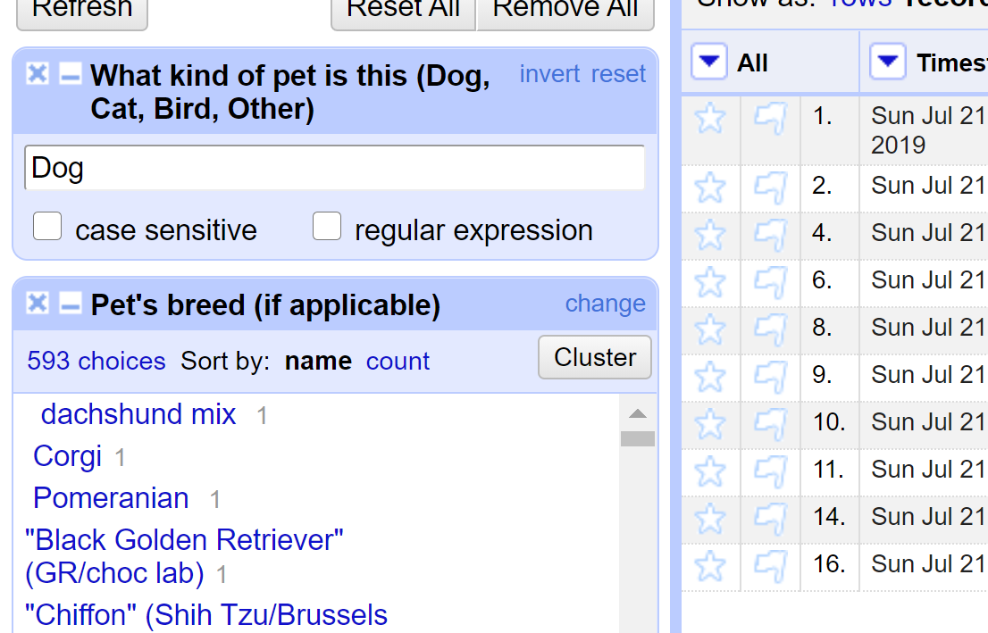

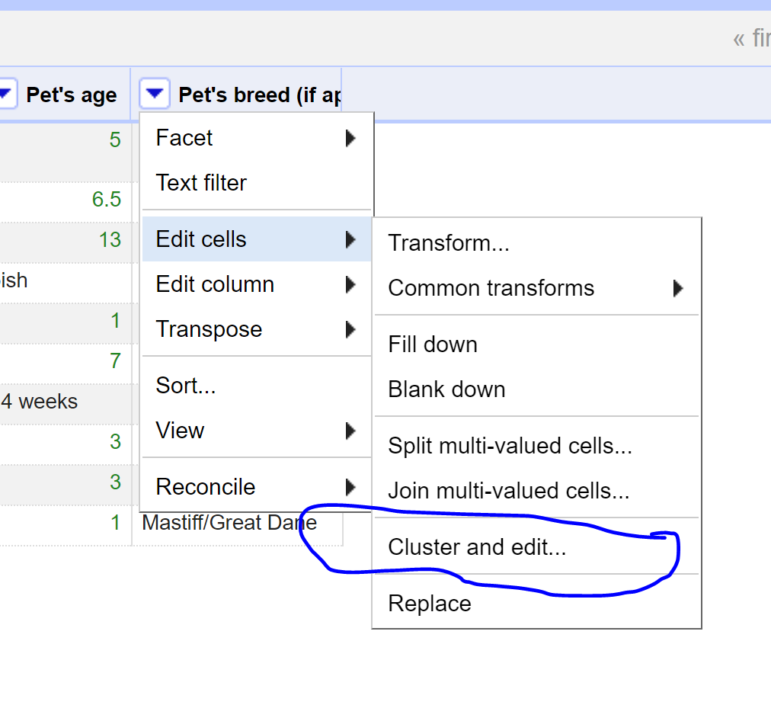

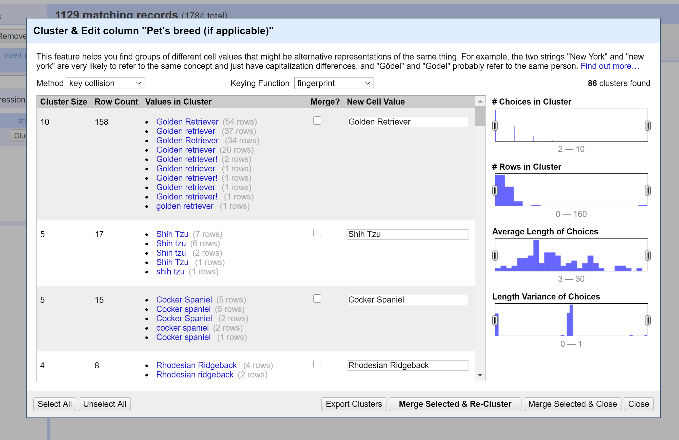

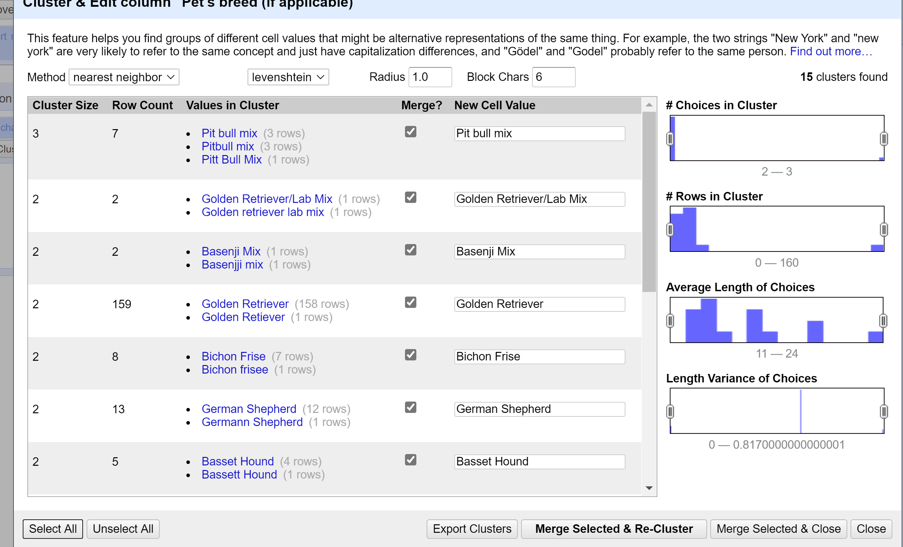

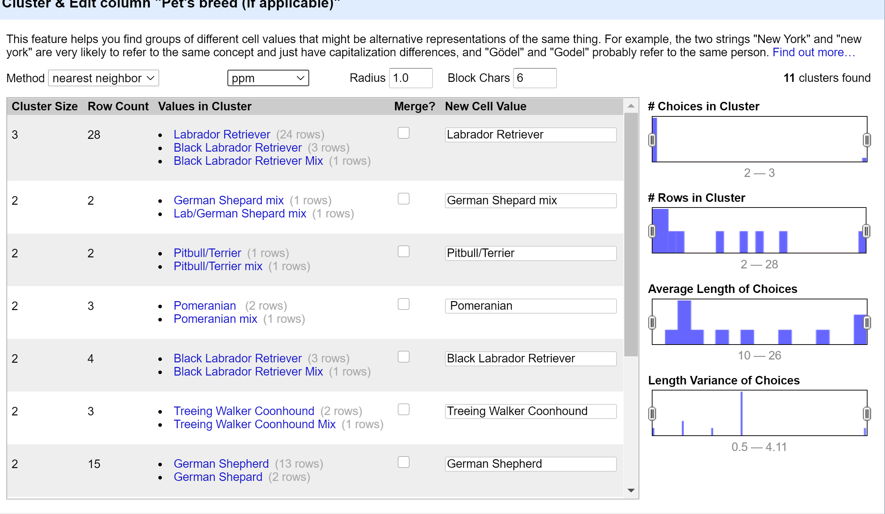

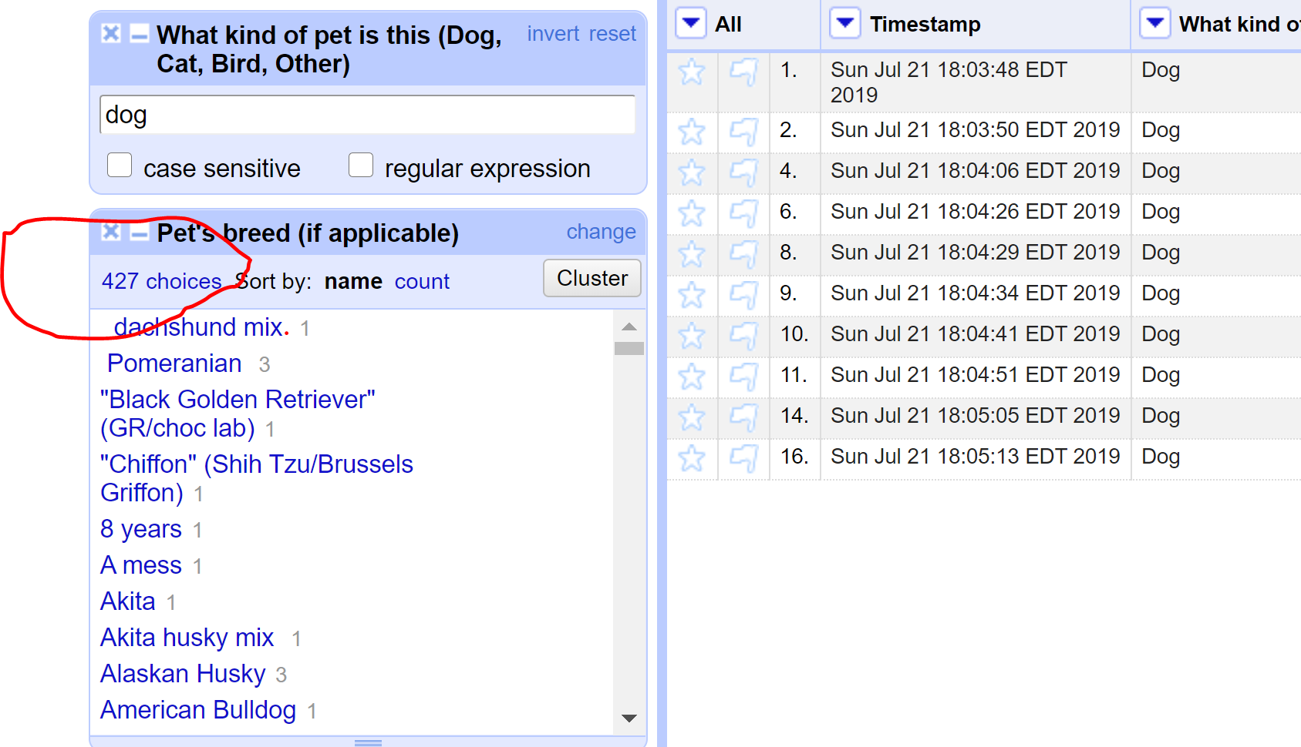

I found that Labrador and Labrador retriever are same, so I replaced them and made them as one.

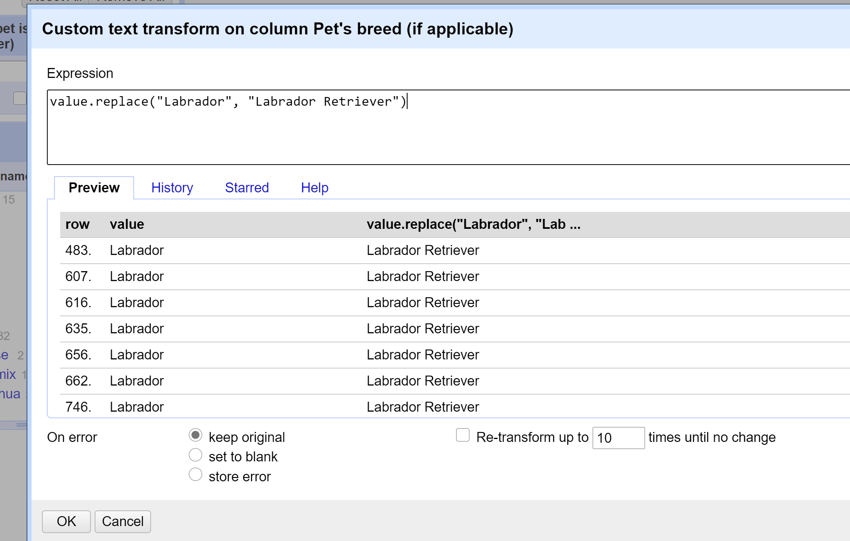

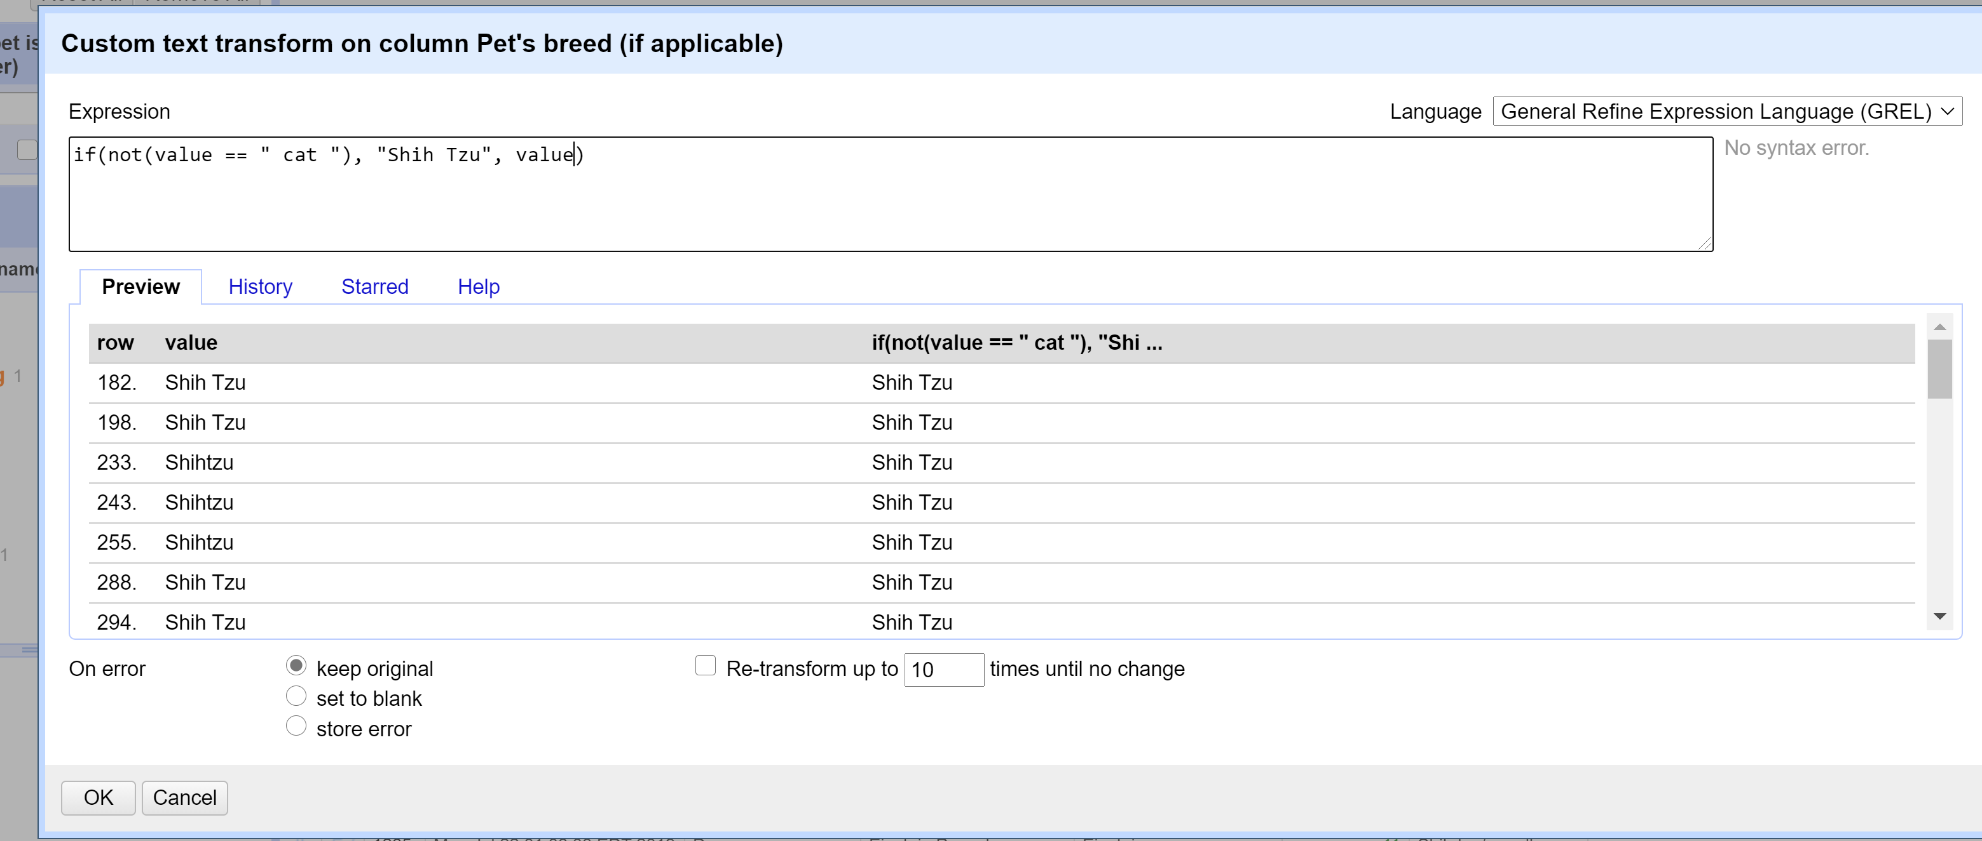

By using

***if(not(value == “ some name which is not in the list”), “ Required name”, value)***

34 cells have been replaced with Shih Tzu.

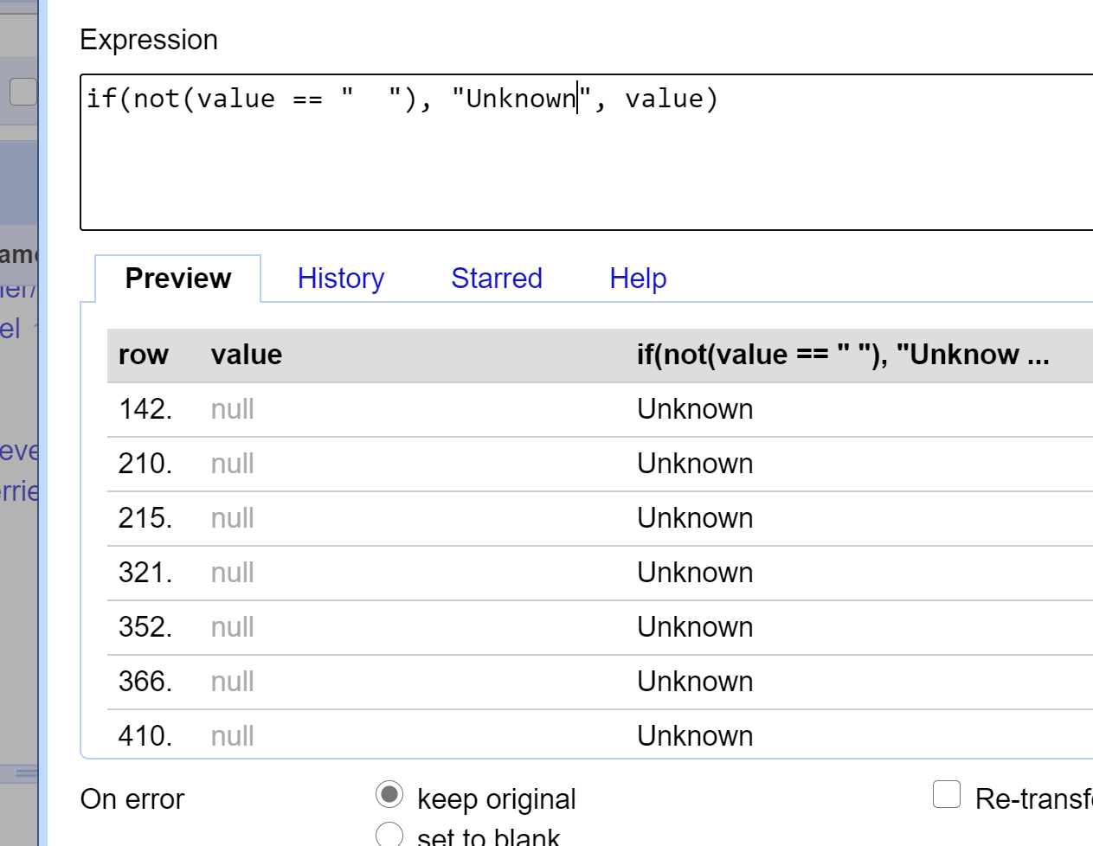

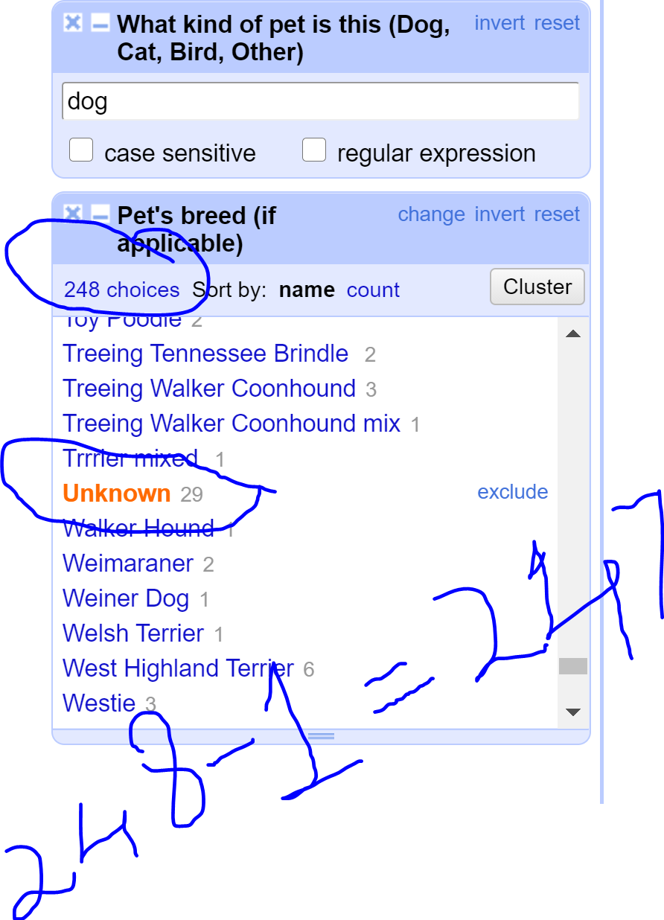

After several filtering methods, I am now left with **247** variety of dog breeds.

1. What's the most popular dog breed?

After finding the pets breeds for dogs and selecting *sort by name count*, I found Golden Retriever is the most popular bread with **172** choices out of 247 choices.

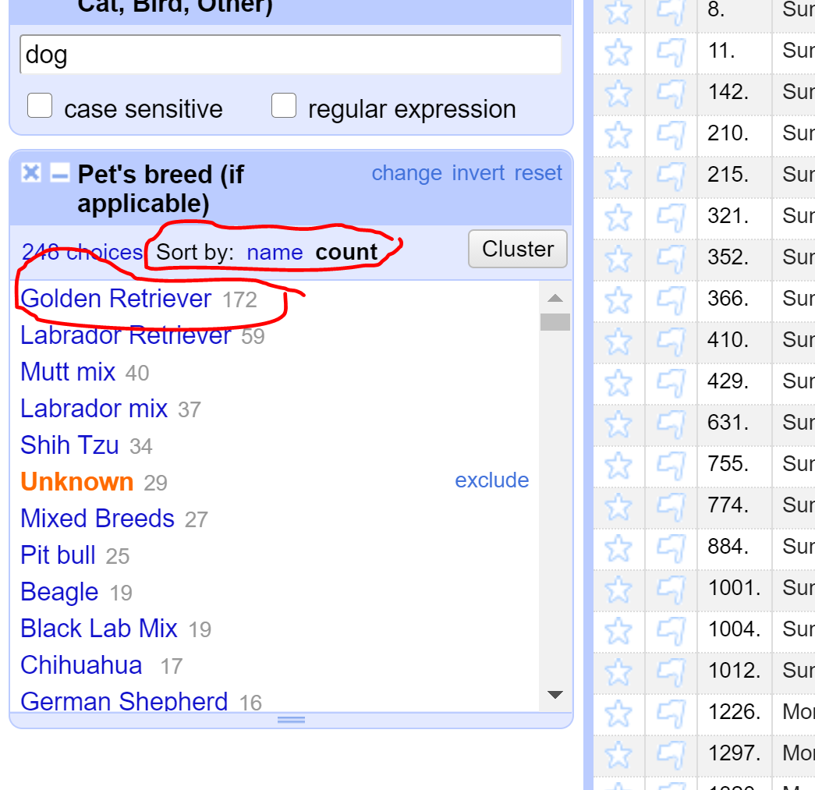

1. What's the age range of the dogs?

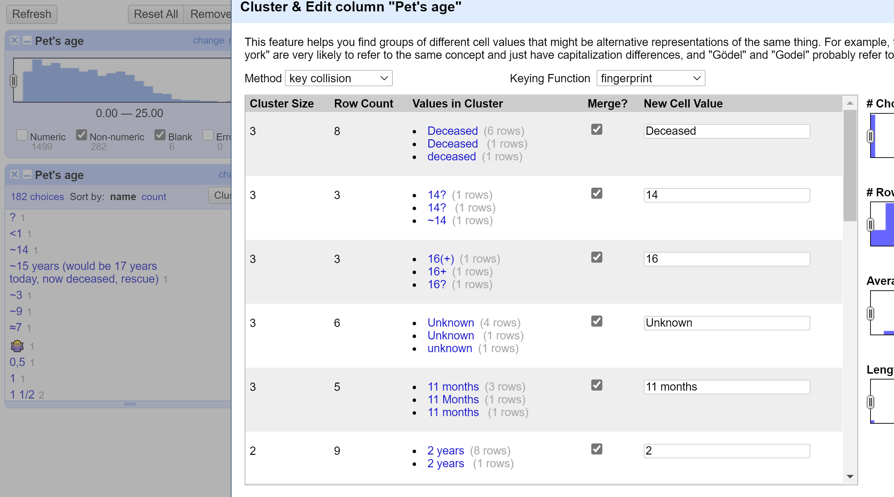

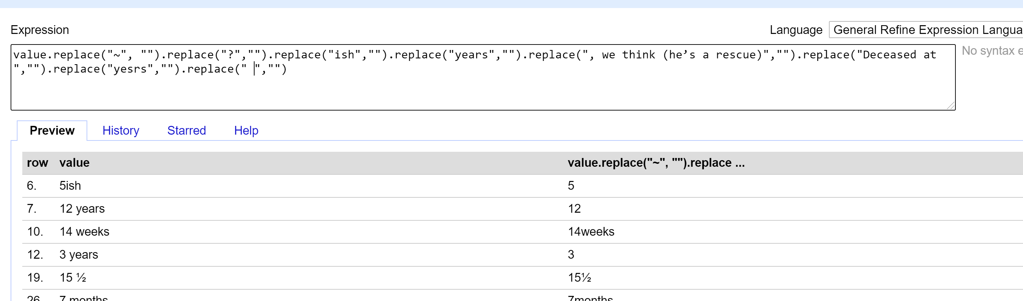

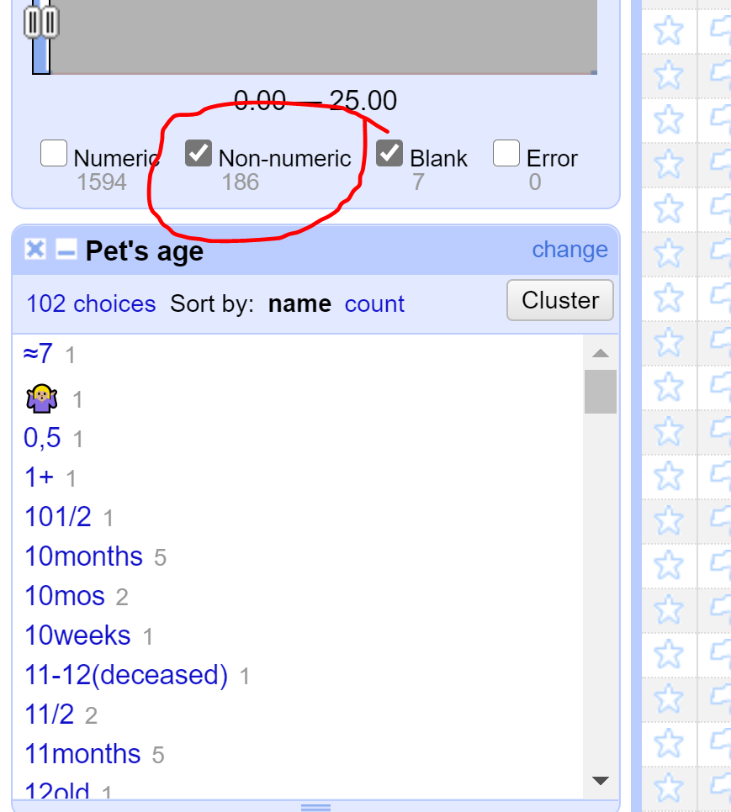

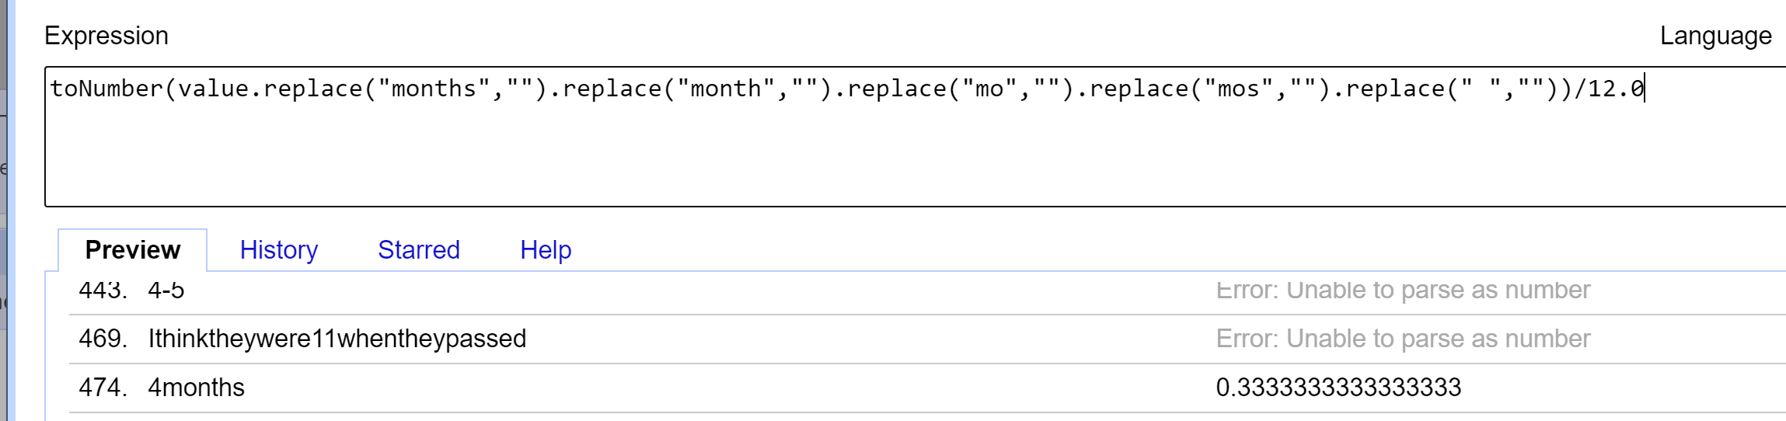

1. What's the age range of the guinea pigs?

Since Guinea Pig belongs to Rodent family, I considered it as a rodent and of the 7 varieties of rodents in the list there are **13** guinea pigs and the age range is between **1 year and 5 years** ( considering the numbers as years). There is one age value as ~4, I considered it as 4 years (probably it could be 0.4 years also).

To identify the age range of guinea pigs, I considered **Text filter** in “What kind of pet” and considered **Rodent**, then there are different names for guinea pigs, I change all of them as guinea pigs.

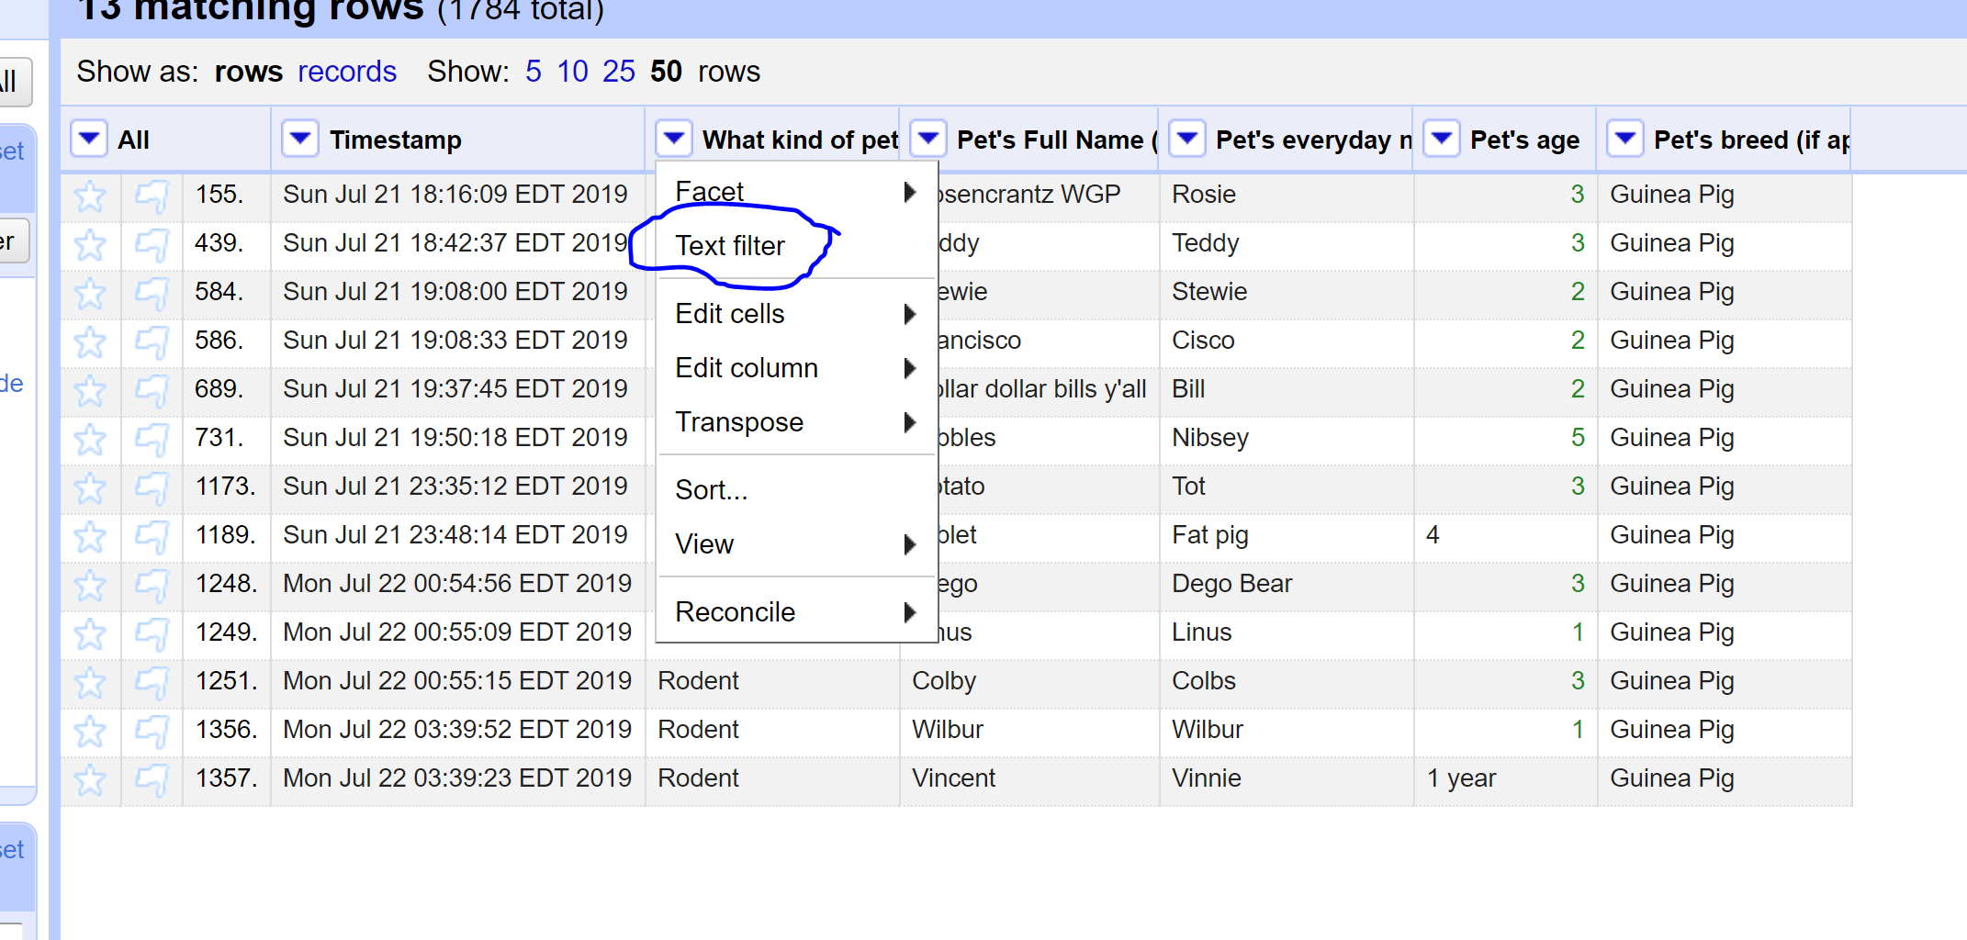

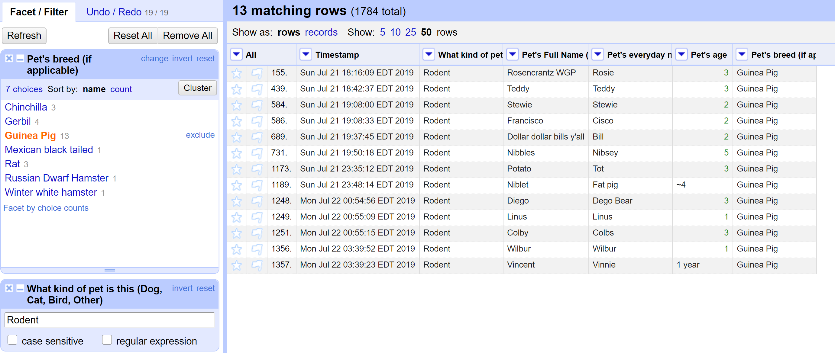

1. What is the oldest pet?

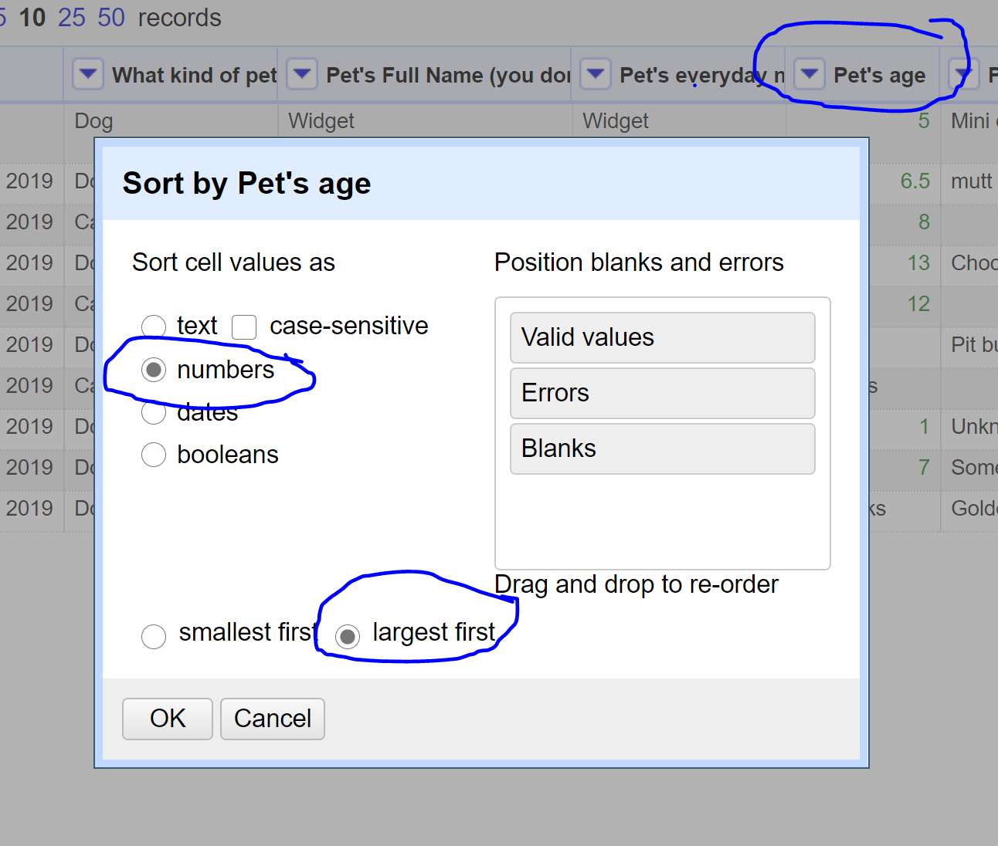

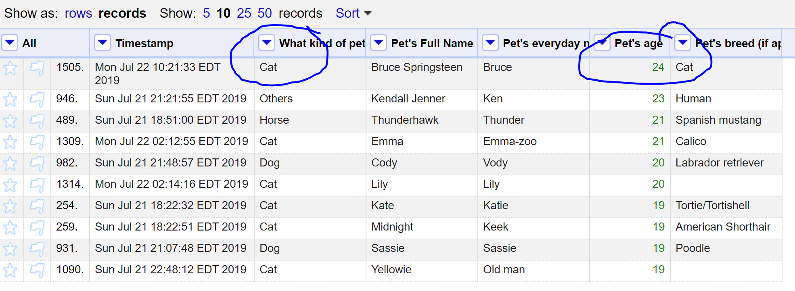

1. Which are more popular, betta fish or goldfish? How many of each?

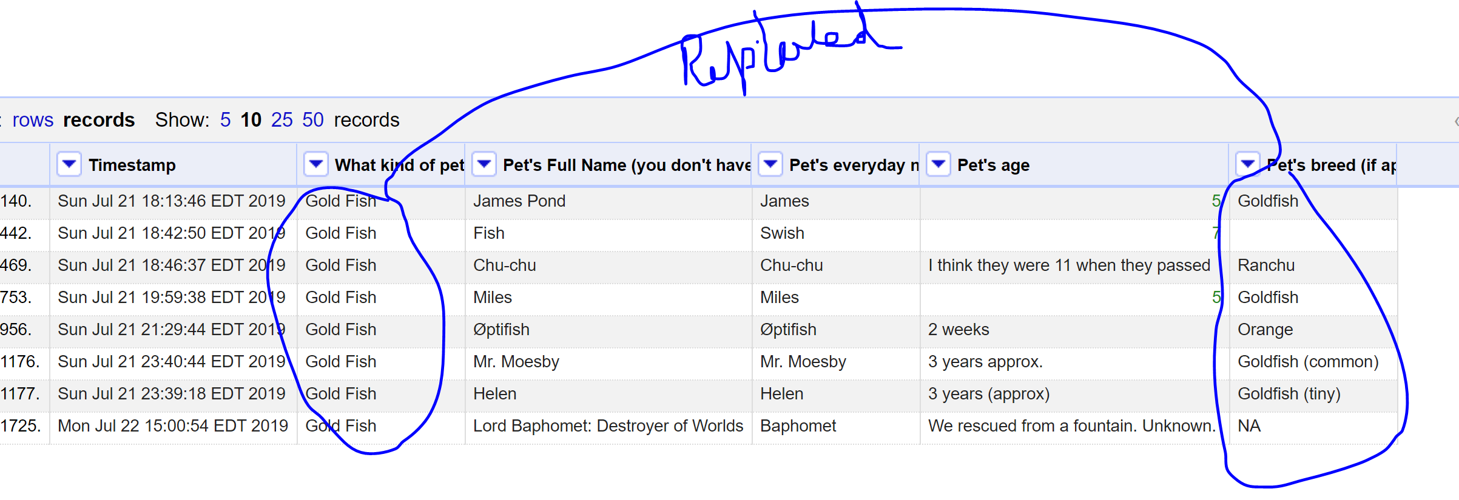

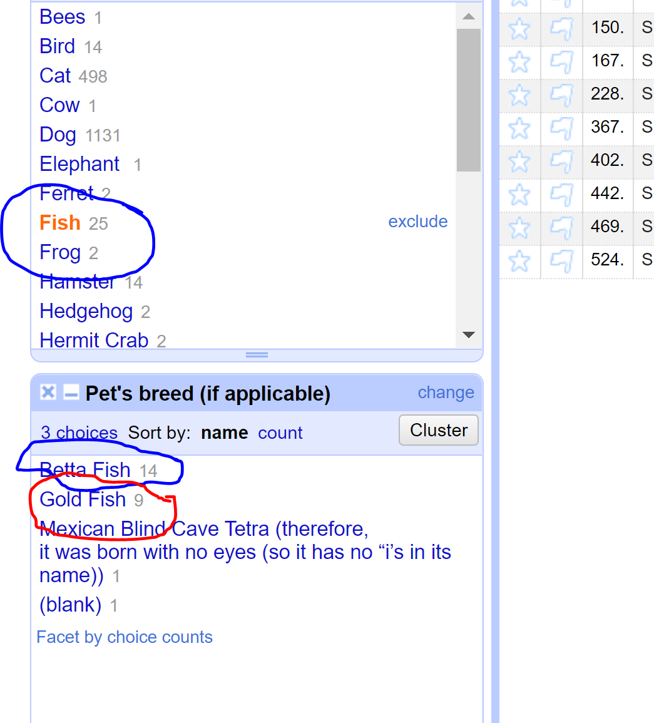

1. What's the most popular everyday name for a cat?
2. What's the most popular full name for a dog?

***References:***

<https://www.bing.com/images/search?q=Wirehaired+Pointer&form=RESTAB&first=1&scenario=ImageBasicHover>

<https://analyticsindiamag.com/openrefine-tutorial-a-tool-for-data-preprocessing-without-code/>

<https://guides.library.illinois.edu/openrefine/combining>

<https://www.bing.com/search?q=Kitty%20Meow%20Torti&qs=n&form=QBRE&sp=-1&pq=kitty%20meow%20torti&sc=0-16&sk=&cvid=79E826906E07478FB26BDE9F40091212>

Labrador and Labrador retriever are same:

<https://www.bing.com/search?q=labrador%20retriever%20and%20%20labrador%20are%20they%20same&qs=n&form=QBRE&sp=-1&pq=labrador%20retriever%20and%20labrador%20are%20they%20same&sc=1-45&sk=&cvid=A9E80E576F61489FBEFC0B83DC91E9B5>

Open Refine Tutorial:

<https://casci.umd.edu/wp-content/uploads/2013/12/OpenRefine-tutorial-v1.5.pdf>